RegimeWise: Group Tax Planning Analyser
Oct 26, 2026 · @Vivek Jaiswal

Project summary
Title: RegimeWise — an analyser that tells a group, company by company, whether and when to opt for the 22% concessional corporate tax regime under Section 200 of the Income-tax Act, 2025 (old section 115BAA of the 1961 Act), and drafts the advisory note with AI.
The problem. The Section 200 (old 115BAA) regime is cheaper in rate, but the choice cannot be reversed once made. Switching forfeits MAT credit and some brought-forward losses, so a company that saves tax this year can pay more over five. Advisors usually compare one year in Excel, company by company, and miss the timing question: switch now, switch later, or never.
How it works
- Enter each company's opening position (losses, unabsorbed depreciation, MAT credit) and a five-year projection of income and book profit.
- A rules engine computes tax year by year under the normal regime, carrying MAT credit and losses forward.
- An optimiser tries every option — stay normal, or switch in year 1, 2, 3, 4 or 5 — and picks the one with the lowest present value of tax.
- The dashboard shows the best option per company, the group saving, and the year-by-year schedule behind it.
- An LLM drafts an advisory note from those numbers only; the CA reviews and signs it.
Objectives
- Compute tax under both regimes over five years, with MAT credit and loss carry-forward.
- Find the best switch year for each company, and the group total saving.
- Flag the trade-offs: credit forfeited, losses blocked, irreversibility, dividend deduction cap.
- Produce a structured draft advisory note for CA review.
- Measure accuracy against hand calculations and time saved against a manual Excel analysis.
Scope. In: domestic companies in one group, five tax years, the normal regime and Section 200 (old 115BAA), MAT, loss and unabsorbed-depreciation set-off, inter-corporate dividend deduction. Out: individuals and firms, the new-manufacturing concessional rate, surcharge marginal relief, MAT credit and loss expiry beyond five years, transfer pricing, and final opinions (the tool drafts; the CA decides).

Solution architecture
RegimeWise is a rules engine with an optimiser on top and an AI drafting step at the end. It runs on your laptop; only the AI note calls an external LLM.
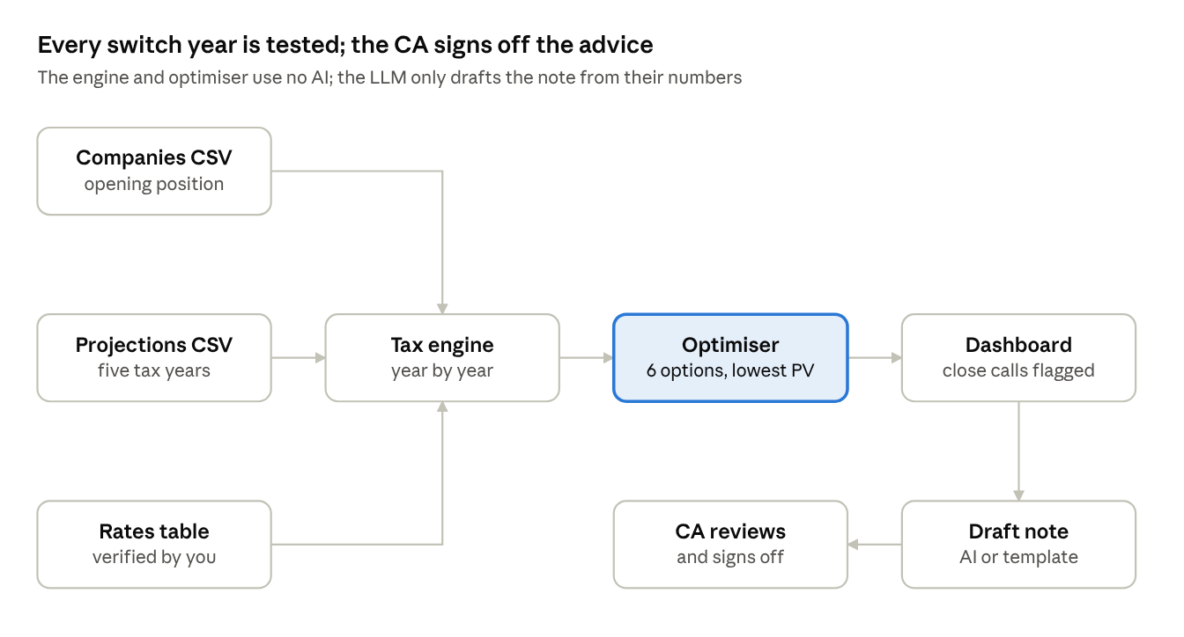
RegimeWise architecture · 8 components
The tax figures never come from the LLM: the engine computes them and is checked against hand calculations. The LLM only turns those figures into prose, which the CA edits.
What the engine does each year
- Normal regime: set off losses, deduct inter-corporate dividends (capped at the amount distributed), then pay the higher of normal tax and MAT. MAT credit is earned when MAT is higher and used when normal tax is higher.
- Section 200 (old 115BAA), from the switch year: MAT credit lapses, blocked losses drop out, and tax is 22% plus 10% surcharge and cess, with no MAT.
- Optimiser: runs all six options per company and ranks them by present value of tax.
What the sample shows. On the invented group, the best options differ by company: ManufCo should switch at once (no MAT credit to lose), HoldCo should wait until its ₹4 crore MAT credit is used up, and TradeCo should wait until its losses are absorbed. That contrast is the heart of your chapter 7: the right answer depends on each company's position, not just the rate.
How to run
- pip install -r requirements.txt
- python test_engine.py — should print 10 of 10 checks passed.
- streamlit run app.py — upload both CSVs from the sidebar.

Evaluation plan
The engine must reproduce a CA's own computation exactly; the optimiser and the AI note are then judged on usefulness. Report every result as a number.
Metric | How measured | Target | Your result
Engine accuracy | Hand-computed years added to test_engine.py (sample plus your group) | 100% match
Optimiser correctness | Best option has the lowest PV in every case | 100%
Robustness | Recommendations that flip across discount rates 0%, 10%, 15% | Report count
Sensitivity | Recommendations that flip with income 20% lower | Report count
AI note accuracy | Figures in the note that do not match the dashboard | 0
AI note usefulness | Sentences you kept unchanged, out of total | Report %
Time saved | Manual Excel analysis vs RegimeWise, minutes | 70%+ saved
Why the flip tests matter. Because the option cannot be withdrawn, a recommendation that changes when the discount rate or projections move a little is a weak one. Showing that you tested this, and flagging close calls, is what makes the tool advisory-grade rather than a calculator.
Error analysis. For any mismatch with your hand computation, say whether the code or the hand working was wrong, and what you fixed.

Risks, ethics and safeguards
The tool supports the CA's recommendation; it never makes it. Because the option is irreversible, the safeguards matter more here than in most tools.
Risk | Safeguard
Wrong rate or rule in the code | All rates in one table, verified against current law; hand-calculated tests that must pass before use
Recommendation rests on optimistic projections | Sensitivity tests; close-call warning when the best option leads by under 5%
Value beyond five years ignored | Unused MAT credit at the end shown for every option; limitation stated in the note
AI note states a wrong figure or invents law | Prompt limits it to the dashboard's numbers; temperature 0; CA edits before sending; template note as fallback
Client confidentiality | Companies anonymised; the model runs on your laptop; only figures, no names, go to the LLM

Professional standards to cite: ICAI Code of Ethics on confidentiality and due care; the Digital Personal Data Protection Act, 2023 for any personal data. The note is a draft; responsibility for the advice stays with the signing CA.

